Galgotias University
Gautam Buddha Nagar
Greater Noida

SMART VEHICLE PARKING SYSTEM

Under the Supervision of
Ms. Vijaya Chaudhary

Bibek Jha(20SCSE1010849)
zhabibek4u@gmail.com
Mohd. Sabeel Aijaz(20SCSE1010852)
Ankit Kumar(20SCSE1300006)

ABSTRACT— One of the most annoying things that happened in our time is to find a parking space and not find it, especially when you should have been somewhere five minutes ago and you are currently looking for a parking space for 20 minutes now. It is due to the increase in the number of vehicles on the road; road problems will inevitably occur. Another reason is that the current transportation infrastructure and upgraded car parks cannot withstand traffic congestion.
However, any problem must have a solution, or multiple solutions, based on the solution and efficiency. There are many solutions for smart parking systems out there, including the introduction of deep learning, weight sensors, light sensors and all those science fictions that revolves around the world these days. To alleviate the problems mentioned above, a clever parking system has been developed. With the help of an intelligent parking system, sponsors can easily find and secure an unoccupied parking lot in any car park that seems convenient for them. This project focuses on one of the best smart parking systems that uses only a webcam and a few lines of code. The concept of this solution is very simple. It is made up of two documents with the following paragraphs: Select parking links and save them in a file and find links in the file and decide if the location is available or not. The reason for separating this solution into two texts is strongly related to avoiding the choice of spots whenever you want to see if there are any spots available especially if the same area is used for previous use.
The proposed system shows the number of parking lots, cars entering the parking lot and also shows the number of cars already parked in the parking lot. It also counts the number of empty spaces. When car leaves space the system will automatically update the number of parking spaces. The future of the smart parking market is expected to be greatly influenced by the advent of automotive vehicles (AVs). Several cities around the world have begun testing car parks, AV parking lots, and robotic parking valets.

  - INTRODUCTION
In recent times, domestic vehicles have become increasingly common with population growth and economic development. Meanwhile, the necessary parking spaces for these vehicles have been in short supply and have become very expensive. This growing inequality is most evident in the attractive landscapes that see an influx of motorists. Finding parking spaces for such places during events is a challenge. Car owners often face the most frustrating process of driving everywhere with unconfirmed searches of available parking spaces. Productive operating hours are wasted, fuel is wasted, and carbon emissions from conventional vehicles are rising. Managers of these areas often turn to providing additional parking spaces to assess the problem. This effort, however, complements the existing problem as finding vacant land becomes more difficult when the area is more than half full. It is therefore clear that the proper management of available space is the most appropriate solution. Contrary to the common use of monitors, intelligent systems that provide easily accessible information of spaces are needed to effectively meet these parking needs.

Globalization has been concentrating on many people in urban areas, causing urban communities such as Bangalore to become overcrowded and under ban. Population growth means population growth and movement. This contributes to an increase in the number of vehicles which contributes to the parking situation. These days, a handful of people are buying cars without having a place to park, and a few roads in any case, which are just parking lots causing a lot of traffic. Ordinary parking lots are usually vacant, and individuals are required to search for the empty one. Not only is this method of parking very convenient, but it also works especially well on high-rise buildings where drivers need to check each area and find different floors to find and be sure of parking.

Open CV
OpenCV (Open-Source Computer Vision) is approved for both educational and commercial use. It is a library of highly targeted editing activities for computer recognition. The OpenCV application has a wide range of features that include 2D and 3D feature tools, Ego movement measurement, face recognition system, touch recognition, motion recognition, object identification segment and movement monitoring and tracking. OpenCV is written in C ++ and the main interface is in C ++, yet despite keeping the old interface is incomplete but old. OpenCV contains pre-defined function libraries that support image processing. As an open source, it has been selected as a project testing platform. Through the use of OpenCV libraries we have used image processing methods such as RGB to convert grayscale, erosion, elasticity.

Python
Python is a widely used language for high-level, general-purpose, interpreted, and flexible editing. Its design philosophy highlights the readability of the code, and its syntax allows programmers to express ideas in smaller lines than would otherwise be possible in languages ​​such as C ++ or Java. Language provides structures that are intended to enable explicit programs on both small and large scales. Python supports multiple editing paradigms, including object-oriented, critical and functional programming processes or styles. It has a flexible type system and automatic memory management and has a large and complete standard library.

1.2 Problem Formulation
One of the most annoying things that happened in our time is to find a parking space and not find it, especially when you should have been somewhere five minutes ago and you are currently looking for a parking space for 20 minutes now. It is due to the increase in the number of vehicles on the road; road problems will inevitably occur. Another reason is that the current transportation infrastructure and upgraded car parks cannot withstand traffic congestion.

Solution through this project:
However, any problem must have a solution, or multiple solutions, based on the solution and efficiency. There are many solutions for smart parking systems out there, including the introduction of deep learning, weight sensors, light sensors and all those science fictions that revolves around the world these days. To alleviate the problems mentioned above, a clever parking system has been developed. With the help of an intelligent parking system, sponsors can easily find and secure an unoccupied parking lot in any car park that seems convenient for them. As car sensory sensors proliferate in the market, the choice made may slow down due to a variety of needs in addition to its advantages and disadvantages.
This project focuses on one of the best smart parking systems that uses only a webcam and a few lines of code. The concept of this solution is very simple. It is made up of two documents with the following paragraphs: Select parking links and save them in a file and find links in the file and decide if the location is available or not. The reason for separating this solution into two texts is strongly related to avoiding the choice of spots whenever you want to see if there are any spots available especially if the same area is used for previous use.

The proposed system shows the number of parking lots, cars entering the parking lot and also shows the number of cars already parked in the parking lot. It also counts the number of empty spaces. When car leaves space the system will automatically update the number of parking spaces.

1.2.1 Algorithm/Tools and Technology Used
A static image file is a video file frame and after the code is extracted, the still image is displayed with the mouse, quadrilateral will be created with its three input points. Links to the input points are stored in the YAML file and the letter ‘q’ will be pressed to start displaying the video feed. Quadrilaterals are created to separate each parking area defined red or green. Red means the computer sees the parking space in the middle of the quadrilateral as a car seat and green means it is available for parking.
The clever parking plan proposed in this paper contains three key components. These parking identification nodes have Wi-Fi hotspots (APs) embedded within each major parking segment, a wireless network area (WLAN) at an integrated local base station, and an information delivery notification system. The structure of the proposed system is shown in Figure 1.
Algorithm: We have used OpenCV library and it’s algorithm to build the application of Smart Parking System.
A static image file is a video file frame and after the code is extracted, the still image is displayed with the mouse, quadrilateral will be created with its three input points. Links to the input points are stored in the YAML file and the letter ‘q’ will be pressed to start displaying the video feed. Quadrilaterals are created to separate each parking area defined red or green. Red means the computer sees the parking space in the middle of the quadrilateral as a car seat and green means it is available for parking.

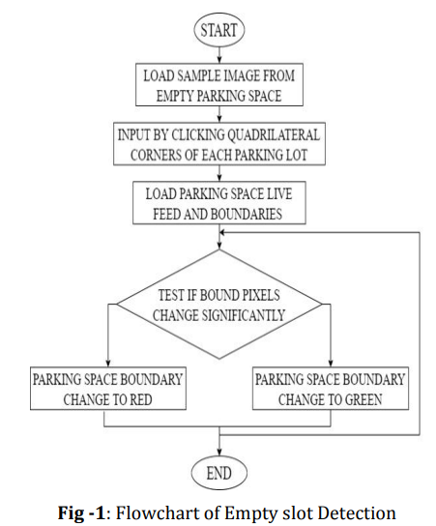

System Architecture: The clever parking plan proposed in this paper contains three key components. These parking identification nodes have Wi-Fi hotspots (APs) embedded within each major parking segment, a wireless network area (WLAN) at an integrated local base station, and an information delivery notification system. The structure of the proposed system is shown in Figure 1.

2.1 LITERATURE SURVEY

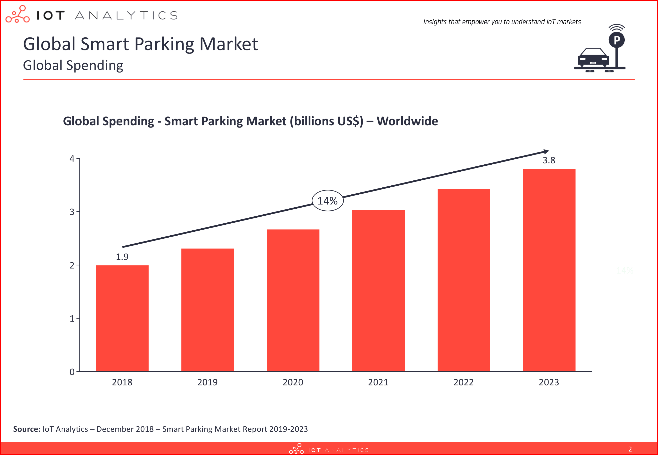
Fig-2 GLOBAL SMART PARKING MARKET
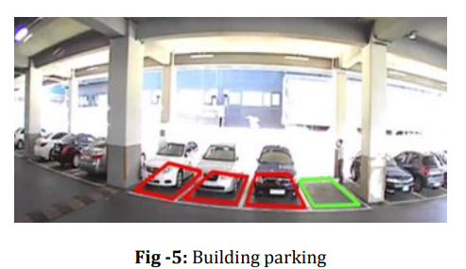
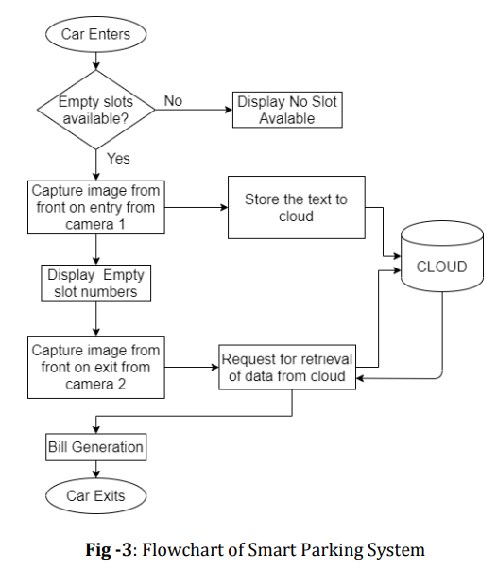
Ming-Yee Chiu et al. proposed a vehicle counting area at the checkpoint which does not count the number of parking spaces available [1]. The calculation is done by inserting the loop sensors into the bottom of the road surface. Although the use of sensors was relatively inexpensive, not easily affected by environmental conditions and obtained with precision however, its installation was difficult and caused damage to roads. It was also difficult to maintain if it was not working properly [2]. Image processing is a hot topic for a long time and there is a lot of development in other applications. Image processing is required in all major sectors of developing and advanced societies such as medicine, security, engineering, entertainment, the media and much more. Different image processing techniques are essential for achieving high accuracy using techniques such as RGB to gray, blurring, threshold and contouring [3] are essential. In some places a large number of images are required to access specific data. The Histogram method is used to obtain statistical data in an image and classify the image as negative or positive [4]. It is also used to familiarize yourself with the image. Email, unwanted or unwanted pieces in a photo using the function of the two-phase Histogram Management Framework to separate and select to dismiss minor unwanted messages in the image using [5]. In obtaining a License Plate the extraction of text is an important purpose in this way image processing becomes the most important part that precedes the image into text conversion. Method 6 [6] uses a corner-focused strategy for extracting text from document images. It has set parameters set for different types of images such as handwritten, typed, slanted, etc. and very fast. Paper [7] proposes a strategy for obtaining a license number in an image taken at different distances and different brightness using waveform and concealment of a potential license. After the processing has been completed and the processed image can be provided with a Tesseract OCR Machine to convert over the image into text using the command line interface [8].

3.1 METHODOLGY AND IMPLEMENTATION

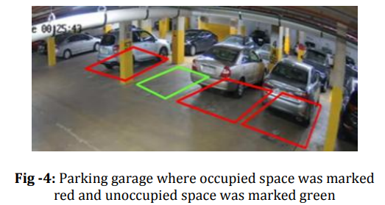

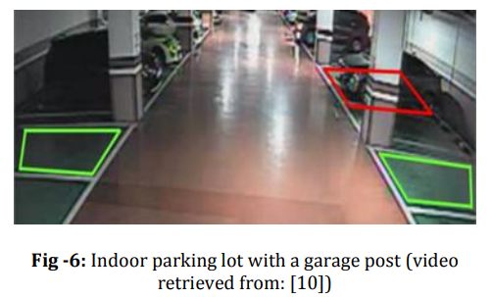
The car enters the parking lot and the parking lot is considered empty. If there is a vehicle number it is scanned using the first camera and stored in the clouds and placed in the parking lot by displaying the available spaces. If no blank spaces are available, the same will appear. When the car goes out then the number plate is scanned and a second camera is used and compared to the time of its arrival. The bill is produced based on the duration of the vehicle's stay.

IMPLEMENTATION

Using the system, the Empty slot detection system has been accurate to indicate whether the parking space is full or not. Figures 4 and 5 show the shape of the parking lot and the structure, which is covered with colored rectangles.
Rectangular areas were set as default before the program was launched. In the case where the car is within a given area of a rectangular shape, the color of the pixel inside will change, and the color in the middle may also vary. This will encourage the system to change color from green to red. However, there are a few situations in which parking may be red regardless of the vehicle you are actually involved in. As shown in Figure 6, any powerful obstacle, for example, a passerby or a garage post that changes the center color of the entire pixel of a limited area can be considered algorithm as a vehicle in these irritating lines. structure to be red.

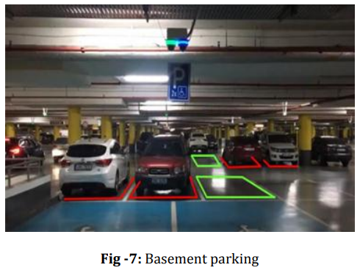
The four-sided regions are heavily dependent on the first static image set aside during the system launch. If the video frame changes the location of the tagged image, the video encryption output will display the square shape removed, as shown in Figure 7. As a result, the frame will work best if the video feed is detected by the presentation. CCTV cameras patrol the parking lot as they stand.
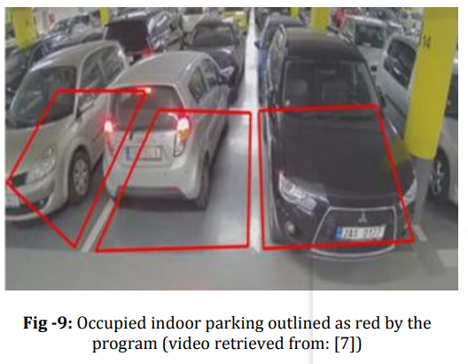
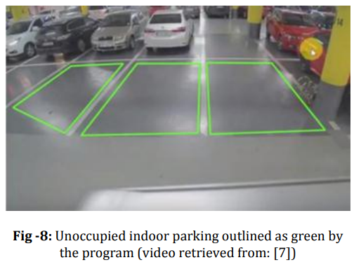
Figures 8 and 9 show the first feed where the marked boxes are shown in green when the road is unfinished, or the available parking area is accessible, therefore, with a standard gray pixel.
At the point where cars take up some parking space, the texture quickly shifts from green to red as the standard color changes.
4.1 RESULT AND CONCLUSION
Image processing is very important in extracting any information from the image. In this study, the proposed smart parking system based on image processing was successfully tested and implemented with a few videos taken from indoor parking garages. The system works precisely in determining whether parking spaces are full or not by displaying a red frame when the car is inside or consuming parking space and later being green when unoccupied. In the acquisition of the number plate, we first used image processing algorithms on images, and later those images were used in Tesseract software to extract text from images. Different images have different text styles, lengths, widths, and fonts, so different images require different levels of digital image processing techniques. In these single image effects, the most appropriate image is then used in Tesseract to get the text in the image. So, after digital image processing, we have achieved better and closer results.

The proposed system has accurately detected the presence of vehicles in the parking lots. The full image mode has done better than the use of extended edge images to take up parking space. These two methods can be combined into a single system. The camera area may be adjusted to improve performance. From the above set of test results, it has been shown that the proposed image-based system is an effective parking space management option. Other technologies such as auto-detection of numbers and traffic light control can be integrated with this system to create more efficient transport systems.

REFERENCES
[1] Ming-Yee Chiu; Depommier, R.; Spindler, T.; , "An embedded realtime vision system for 24- hour indoor/outdoor car-counting applications," Pattern Recognition, 2004.
[2] Zhang Bin; Jiang Dalin; Wang Fang; Wan Tingting; , "A design of parking space detector based on video image," Electronic Measurement & Instruments, 2009.
[3] F. Zhou, and Q. Li, “Parking guidance system based on ZigBee and geomagnetic sensor technology,” 13th International Symposium on Distributed Computing and Applications to Business Engineering and Science (DCABES) 2014, pp. 268-271.
[4] Y. Zheng, S. Rajasegarar, and C. Leckie, “Parking availability prediction for sensor-enabled car parks in smart cities,” IEEE 10th International Conference on Intelligent Sensors Sensor Networks and Information Processing (ISSNIP) 2015, pp. 1-6.
[5] A. Khanna, and R. Anand, “IoT based smart parking system,” 2016 International Conference on Internet-ofThings and Applications (IOTA), Pune, 2016, pp. 266-270.
[6] Z. Ji, I. Ganchev, M. O'droma, and X. Zhang, “A cloud-based intelligent car parking services for smart cities,” General Assembly and Scientific Symposium (URSI GASS) 2014 XXXIth URSI, pp. 1- 4.

[7] K. Cheng, “Indoor Parking DAHUA,” 2018. [Online]. Available: https://www.youtube.com [Accessed 2018].

[8] KETOSI, “[KETOSI] Audi R8 V10 Parking Lot Accident CCTV,” 2013. [Online]. Available: https://www.youtube.com [Accessed 2018].

